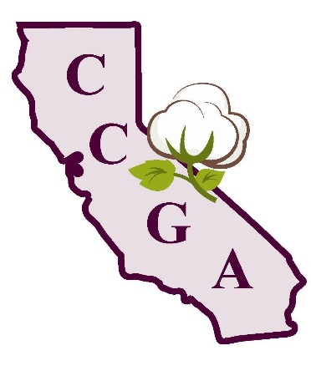
California Cotton Growers Association

1785 N. Fine Avenue
Fresno, CA 93727
Phone: (559)252-0684
Fax: (559)252-0551

2015 Annual Meeting of the
California Cotton Growers Association

Visalia Convention Center
Visalia, California

March 6th, 2015

Registration Form

Company Name: ______________________________________________

Contact: ________________________ email: __________________________

Breakout Session Choice

Check the one you will be attending (complete the form for each attendee) –

 | Pest and Products | - 2014 Insect Review  - New Product Updates
 | Cotton Variety Update | - 2014 Variety Trial Results  - New Variety Updates
 | Water – Issues and Irrigation Efficiency | - Groundwater Update  - Nitrates & ILRP Update  - Pump Testing

Registration begins at 8:00 am, with meeting starting promptly at 9:00 ending with a free lunch at noon!

Please fax this form to (559) 252-0551 promptly.
This event is FREE, but you must register!

